Classification Notes
Thresholds and the confusion matrix
Let's say you have a logistic regression model for spam-email detection that predicts a value between 0 and 1, representing the probability that a given email is spam. A prediction of 0.50 signifies a 50% likelihood that the email is spam, a prediction of 0.75 signifies a 75% likelihood that the email is spam, and so on.
You'd like to deploy this model in an email application to filter spam into a separate mail folder. But to do so, you need to convert the model's raw numerical output (e.g., 0.75) into one of two categories: "spam" or "not spam."
To make this conversion, you choose a threshold probability, called a classification threshold. Examples with a probability above the threshold value are then assigned to the positive class, the class you are testing for (here, spam). Examples with a lower probability are assigned to the negative class, the alternative class (here, not spam).

You may be wondering: what happens if the predicted score is equal to the classification threshold (for instance, a score of 0.5 where the classification threshold is also 0.5)? Handling for this case depends on the particular implementation chosen for the classification model. The Keras library predicts the negative class if the score and threshold are equal, but other tools/frameworks may handle this case differently.
Suppose the model scores one email as 0.99, predicting that email has a 99% chance of being spam, and another email as 0.51, predicting it has a 51% chance of being spam. If you set the classification threshold to 0.5, the model will classify both emails as spam. If you set the threshold to 0.95, only the email scoring 0.99 will be classified as spam.
While 0.5 might seem like an intuitive threshold, it's not a good idea if the cost of one type of wrong classification is greater than the other, or if the classes are imbalanced. If only 0.01% of emails are spam, or if misfiling legitimate emails is worse than letting spam into the inbox, labeling anything the model considers at least 50% likely to be spam as spam produces undesirable results.

Confusion matrix
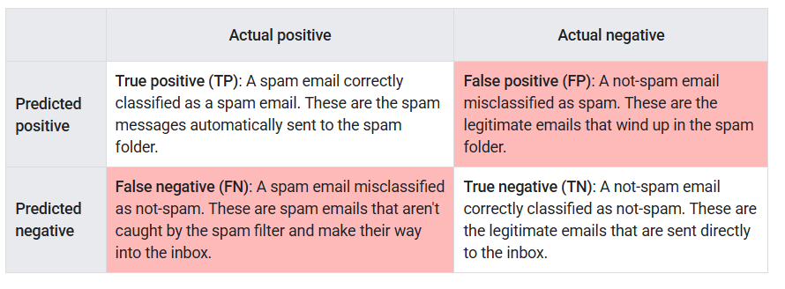
Notice that the total in each row gives all predicted positives (TP + FP) and all predicted negatives (FN + TN), regardless of validity. The total in each column, meanwhile, gives all real positives (TP + FN) and all real negatives (FP + TN) regardless of model classification.
When the total of actual positives is not close to the total of actual negatives, the dataset is imbalanced. An instance of an imbalanced dataset might be a set of thousands of photos of clouds, where the rare cloud type you are interested in, say, volutus clouds, only appears a few times.

Accuracy
Accuracy is the proportion of all classifications that were correct, whether positive or negative. It is mathematically defined as:
A perfect model would have zero false positives and zero false negatives and therefore an accuracy of 1.0, or 100%.
However, when the dataset is imbalanced, or where one kind of mistake (FN or FP) is more costly than the other, which is the case in most real-world applications, it's better to optimize for one of the other metrics instead.
For heavily imbalanced datasets, where one class appears very rarely, say 1% of the time, a model that predicts negative 100% of the time would score 99% on accuracy, despite being useless.

Recall, or true positive rate
The true positive rate (TPR), or the proportion of all actual positives that were classified correctly as positives, is also known as recall.
Recall is mathematically defined as:
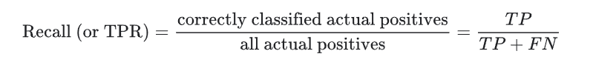

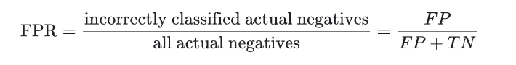
In an imbalanced dataset where the number of actual positives is very low, recall is a more meaningful metric than accuracy because it measures the ability of the model to correctly identify all positive instances. For applications like disease prediction, correctly identifying the positive cases is crucial. A false negative typically has more serious consequences than a false positive.

False positive rate
The false positive rate (FPR) is the proportion of all actual negatives that were classified incorrectly as positives, also known as the probability of false alarm. It is mathematically defined as:
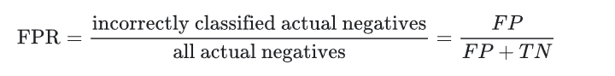
False positives are actual negatives that were misclassified, which is why they appear in the denominator. In the spam classification example, FPR measures the fraction of legitimate emails that were incorrectly classified as spam, or the model's rate of false alarms.
A perfect model would have zero false positives and therefore a FPR of 0.0, which is to say, a 0% false alarm rate.
In an imbalanced dataset where the number of actual negatives is very, very low, say 1-2 examples in total, FPR is less meaningful and less useful as a metric.

Precision
Precision is the proportion of all the model's positive classifications that are actually positive. It is mathematically defined as:
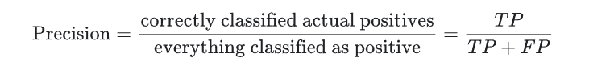
In the spam classification example, precision measures the fraction of emails classified as spam that were actually spam.
A hypothetical perfect model would have zero false positives and therefore a precision of 1.0.
In an imbalanced dataset where the number of actual positives is very, very low, say 1-2 examples in total, precision is less meaningful and less useful as a metric.
Precision improves as false positives decrease, while recall improves when false negatives decrease. But as seen in the previous section, increasing the classification threshold tends to decrease the number of false positives and increase the number of false negatives, while decreasing the threshold has the opposite effects. As a result, precision and recall often show an inverse relationship, where improving one of them worsens the other.

Choice of metric and tradeoffs
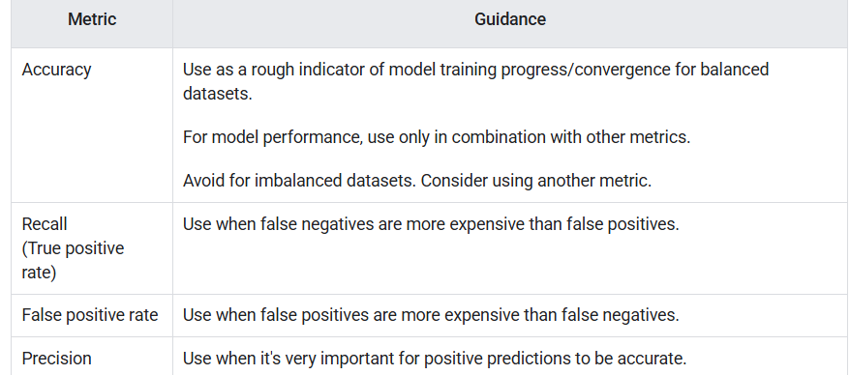

F1score
The F1 score is the harmonic mean (a kind of average) of precision and recall.
Mathematically, it is given by:
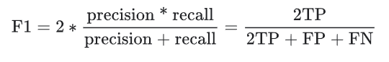
This metric balances the importance of precision and recall, and is preferable to accuracy for class-imbalanced datasets. When precision and recall both have perfect scores of 1.0, F1 will also have a perfect score of 1.0. More broadly, when precision and recall are close in value, F1 will be close to their value. When precision and recall are far apart, F1 will be similar to whichever metric is worse.

Classification: ROC and AUC
The previous section presented a set of model metrics, all calculated at a single classification threshold value. But if you want to evaluate a model's quality across all possible thresholds, you need different tools.

Receiver-operating characteristic curve (ROC)
The ROC curve is a visual representation of model performance across all thresholds. The long version of the name, receiver operating characteristic, is a holdover from WWII radar detection.
The ROC curve is drawn by calculating the true positive rate (TPR) and false positive rate (FPR) at every possible threshold (in practice, at selected intervals), then graphing TPR over FPR. A perfect model, which at some threshold has a TPR of 1.0 and a FPR of 0.0, can be represented by either a point at (0, 1) if all other thresholds are ignored, or by the following:
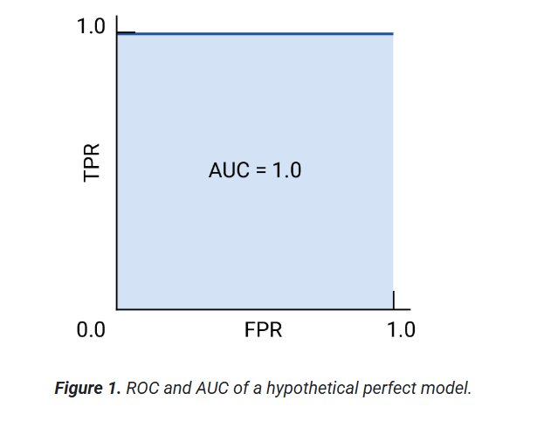

Area under the curve (AUC)
The area under the ROC curve (AUC) represents the probability that the model, if given a randomly chosen positive and negative example, will rank the positive higher than the negative.
The perfect model above, containing a square with sides of length 1, has an area under the curve (AUC) of 1.0. This means there is a 100% probability that the model will correctly rank a randomly chosen positive example higher than a randomly chosen negative example.
In more concrete terms, a spam classifier with AUC of 1.0 always assigns a random spam email a higher probability of being spam than a random legitimate email. The actual classification of each email depends on the threshold that you choose.
In the spam classifier example, a spam classifier with AUC of 0.5 assigns a random spam email a higher probability of being spam than a random legitimate email only half the time.

(Optional, advanced) Precision-recall curve
AUC and ROC work well for comparing models when the dataset is roughly balanced between classes. When the dataset is imbalanced, precision-recall curves (PRCs) and the area under those curves may offer a better comparative visualization of model performance. Precision-recall curves are created by plotting precision on the y-axis and recall on the x-axis across all thresholds.
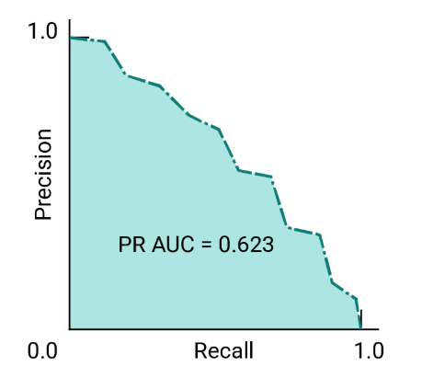

AUC and ROC for choosing model and threshold
AUC is a useful measure for comparing the performance of two different models, as long as the dataset is roughly balanced. The model with greater area under the curve is generally the better one.
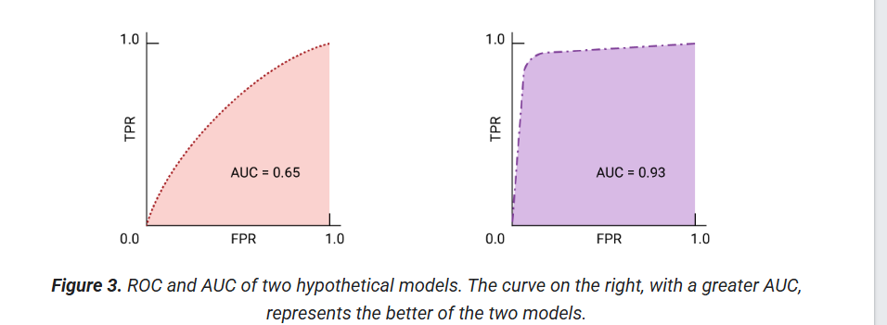
The points on a ROC curve closest to (0,1) represent a range of the best-performing thresholds for the given model. As discussed in the Thresholds, Confusion matrix and Choice of metric and tradeoffs sections, the threshold you choose depends on which metric is most important to the specific use case. Consider the points A, B, and C in the following diagram, each representing a threshold:
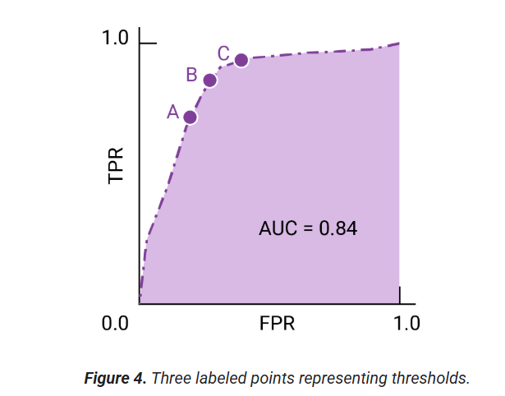
If false positives (false alarms) are highly costly, it may make sense to choose a threshold that gives a lower FPR, like the one at point A, even if TPR is reduced. Conversely, if false positives are cheap and false negatives (missed true positives) highly costly, the threshold for point C, which maximizes TPR, may be preferable. If the costs are roughly equivalent, point B may offer the best balance between TPR and FPR.

Classification: Prediction bias
Prediction bias is the difference between the mean of a model's predictions and the mean of ground-truth labels in the data. A model trained on a dataset where 5% of the emails are spam should predict, on average, that 5% of the emails it classifies are spam. In other words, the mean of the labels in the ground-truth dataset is 0.05, and the mean of the model's predictions should also be 0.05. If this is the case, the model has zero prediction bias. Of course, the model might still have other problems.
If the model instead predicts 50% of the time that an email is spam, then something is wrong with the training dataset, the new dataset the model is applied to, or with the model itself. Any significant difference between the two means suggests that the model has some prediction bias.
Prediction bias can be caused by:
- Biases or noise in the data, including biased sampling for the training set
- Too-strong regularization, meaning that the model was oversimplified and lost some necessary complexity
- Bugs in the model training pipeline
- The set of features provided to the model being insufficient for the task

Classification: Multi-class classification
Multi-class classification can be treated as an extension of binary classification to more than two classes. If each example can only be assigned to one class, then the classification problem can be handled as a binary classification problem, where one class contains one of the multiple classes, and the other class contains all the other classes put together. The process can then be repeated for each of the original classes.
For example, in a three-class multi-class classification problem, where you're classifying examples with the labels A, B, and C, you could turn the problem into two separate binary classification problems. First, you might create a binary classifier that categorizes examples using the label A+B and the label C. Then, you could create a second binary classifier that reclassifies the examples that are labeled A+B using the label A and the label B.
An example of a multi-class problem is a handwriting classifier that takes an image of a handwritten digit and decides which digit, 0-9, is represented.

